State of Utah Labor Commission
Jaceson R. Maughan
Commissioner
Utah Occupational Safety and Health Division
Floyd C. Johnson
Division Director

Dear Ms. Rous,

Thank you for the opportunity to participate in the FY 2022 Follow-Up FAME of the Utah Occupational Safety and Health (UOSH) Division of the Utah Labor Commission. It is a pleasure working with you and your staff, and UOSH looks forward to continuing to build a mutually beneficial relationship with Region VIII. This letter will serve as UOSH’s formal response to the specific findings and observations set forth in the FY 2022 Follow-Up FAME.

UOSH responds specifically as follows to the observations in the FY 2022 Follow-Up FAME:

Observation FY 2022-OB-01 (previously FY2021-OB-03) In FY 2021, two of two (100%) closed inspections resulted in FTA violations, but the penalty amounts for both inspections were significantly below those outlined by the State Plan’s FOM for Failure to Abate (FTA) violations.

UOSH Response: UOSH management has taken actions to refine its internal procedures for the Compliance Safety and Health Officers (CSHOs) to address this Observation. During FY 2022, UOSH developed a written policy regarding FTA cases and calculation of penalty. UOSH has provided training to management, supervisors and CSHO’s as a corrective measure so as to mitigate and discontinue the occurrence of this observation.

Additionally, two observations which were continued from FY 2021 were resolved and as a result, closed in this FY 2022 Follow-Up FAME.

UOSH remains committed to its mission to ensure a safe and healthy workplace for every worker in Utah.

Sincerely,
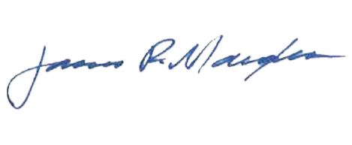
Jaceson R. Maughan
Commissioner
Utah Labor Commission

