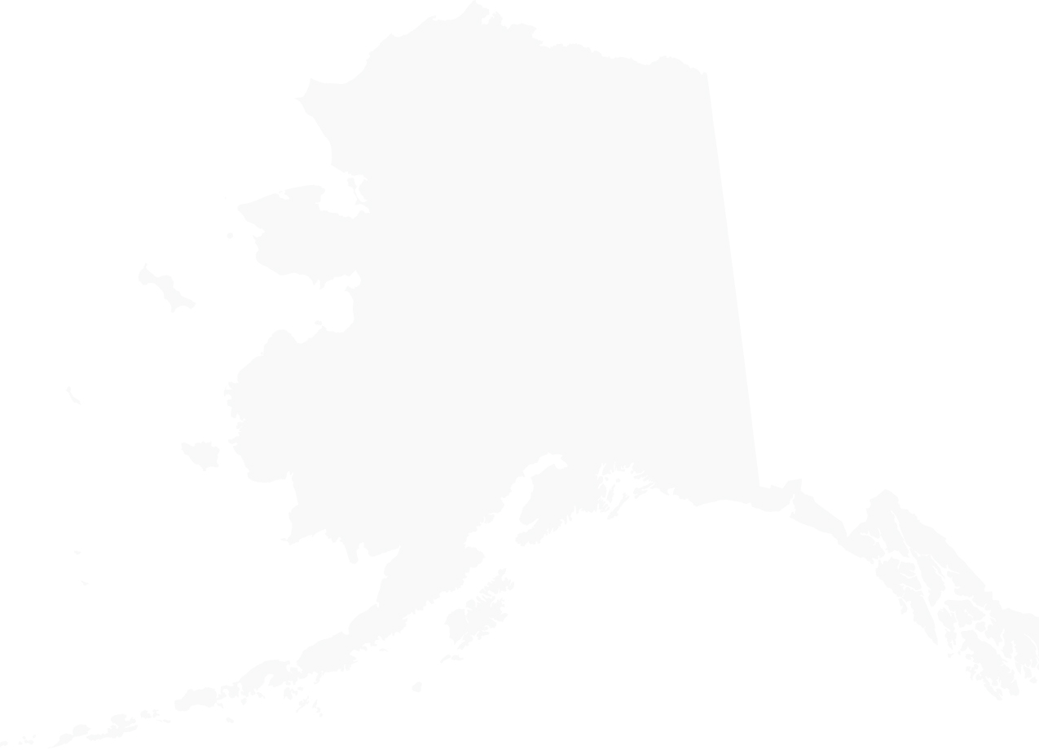

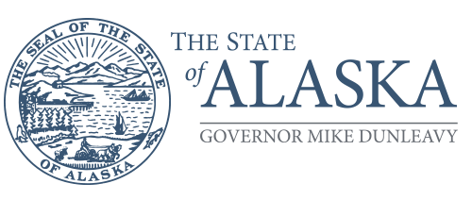Department of Labor and Workforce Development

Labor Standards and Safety Division

Office of the Director

Post Office Box 111149 Juneau, AK 99811

Main: 907.465.3303

Fax: 907.465.6012

July 5, 2024 Dorinda Hughes

Regional Administrator

Occupational Safety and Health Administration

300 5th Avenue, Suite 1280 Seattle, WA 98104-2397 Re: Alaska OSHA’s response to FY23 FAME

Dear Ms. Hughes,

Thank you for the opportunity to partner with federal OSHA and to work collaboratively during the fiscal year (FY) 2023 FAME process to ensure the State of Alaska’s Occupational Safety and Health (AKOSH) program continues to be effective at protecting the safety and health of workers. AKOSH prides itself on continual improvement and truly values constructive input and feedback. We wish to formally dispute findings 2023-01 and 2023-02 in the 2023 FAME Report and request this letter be posted with the FAME Report on the OSHA webpage.

AKOSH requested case file review notes made by OSHA during the 2023 FAME review process. When OSHA provided these review notes, they contained numerous comments that demonstrated a lack of understanding by the reviewer on several issues. For example, OSHA reviewed concurrent inspection case files for multi-employer inspections, but not all the associated case files, and incorrectly found errors in them. When OSHA provided the draft of the 2023 FAME report, errors made by the reviewer were reflected in the initial draft findings.

AKOSH raised these concerns to OSHA. Some concerns were addressed, but others were ignored. While AKOSH is concerned regarding the overall inaccuracy of OSHA’s review of the case files, our biggest concerns lie with OSHA’s findings listed below:

FY 2023-01: In FY 2023, in 16 out of 53 case files (30%) there were no employee interviews documented.

The word “interview” appeared a total of 22 times in the review notes. Many of these comments were referencing the same case file multiple times, resulting in a total of 14 individual case files. Of the comments referencing the individual case files, 1 was a positive comment, 3 comments were for records-only inspections, 3 comments were incorrect due to employee interviews being located in other case files, and 1 case file contained a field notes interview rather than a formal statement. AKOSH acknowledges that six case files did lack employee interviews, which is 11.32%. OSHA failed to account for employer/employee relationships as they related to multiple employers across a fatality case, incorrectly stating that employee interviews were not conducted. Employee interviews associated with the fatality were conducted but were included

in unprogrammed/related case files due to the nature of the relationships that existed between the decedent and other employers. Additionally, OSHA failed to account for the fact that some of the inspections identified were opened as records only inspections due to employers’ failure to report an injury within the statutorily required 8-hour time frame. The facts surrounding the employee injury and the timeliness of the report being made were not in dispute, therefore no employee interviews were required in those cases.

FY 2023-02: In FY 2023, in 15 of 17 (88%) of inspections with citations where an informal conference was held, the penalty reductions were not justified for inspections in which serious high-gravity citations and disabling injuries occurred.

Upon review of this initial comment, AKOSH requested clarification from OSHA. The term “justified” is vague, ambiguous, and subject to interpretation. All of AKOSH’s informal conferences were conducted following AKOSH’s FOM, which was submitted to OSHA for review in 2021 and has yet to be formally approved. In an email to Chief Williamson dated March 28, 2024, AD Lamont provided guidance to review OSHA’s Directorate of Enforcement Programs (DEP) memo from September 18, 2013, which states in part:

*5. Once the discussion of the citation(s) is concluded, the AD should determine what are the expectations of the employer(s), (if any). Usually, the employer(s) will ask for penalty reductions; citation reclassification, both penalty reduction and reclassification, or possibly vacating the citation(s). Depending upon the extent of safety and health efforts by the employer(s), and any other pertinent information established during the course of the settlement proceedings, the AD should use his/her professional judgment in evaluating a settlement offer.*

The State of Alaska operates an independent Occupational Safety and Health plan which was granted final approval by Federal OSHA on September 28, 1984. The Governor of Alaska is the Chief Executive Officer of the State. In September 2023, Commissioner Designee Muñoz and Director of Labor Standards and Safety Tanya Keith received direction from Governor Dunleavy to devise a program in the Department to utilize its discretion in a proactive manner to better facilitate healthier safety cultures in employers’ establishments while ensuring that employees’ health and safety in the workplace is not compromised. As a result, AKOSH was provided with the internal memo which was transmitted to OSHA at 13:21 on September 7, 2023. At 14:53 on September 7, 2023, OSHA requested the memo be rescinded. Chief Williamson discussed this memo with Doug Kalinowski, Directorate of Cooperative State Plans at an OSHSPA meeting and provided him with a copy of the memo. Mr. Kalinowski stated that his assessment was this was a pilot program and did not appear to have any significant concerns. Alaska declined to rescind the memo.

On February 8, 2024, Commissioner Designee Muñoz received a letter from OSHA outlining concerns about the program and asking that the memo either be revised to address their concerns or rescinded. On March 22, 2024, Alaska responded with a revised diversionary program memo, along with a letter from Commissioner Designee Muñoz, stating that although some adjustments were made to the memo to alleviate some of OSHA’s concerns, Alaska disagreed that the policy did not meet ALEA, and Alaska believes that the AKOSH program effectively provides for the development and enforcement of safety and health standards for Alaskans.

On June 17, 2024, OSHA held a meeting with AKOSH and the State of Alaska’s Department of Labor Executive Leadership team to inform us that they had concluded that At Least Effective As (ALEA) concerns no longer existed with the Diversionary Program. However, despite numerous requests by AKOSH, OSHA has yet to demonstrate this FAME finding is supported by OSHA policy, the Federal FOM, the DEP Memo dated September 18, 2013, the AKOSH FOM, or any procedure or guidance issued by OSHA. OSHA has also failed to provide AKOSH with any measurable deficiency regarding the justification of how AKOSH has disposed of any penalties or citations. As a result of this meeting, AKOSH agreed to adjust the language in the memo as requested by OSHA regarding hazard abatements following Consultation and Training’s typical requirements.

AKOSH understands that OSHA is charged with monitoring all State Plans to ensure their effectiveness and values opportunities to be provided with feedback to improve the Administration of our program. We look forward to resolving this issue.

Sincerely,

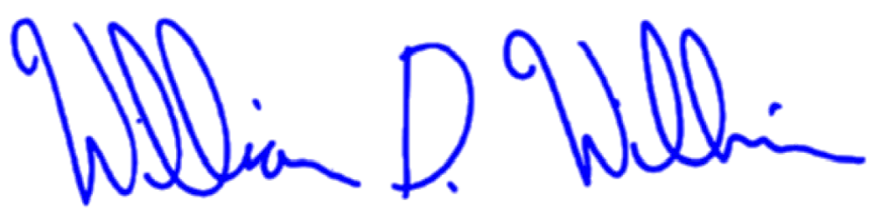

William “Dale” Williamson Chief of Enforcement

Alaska Occupational Safety and Health (AKOSH)