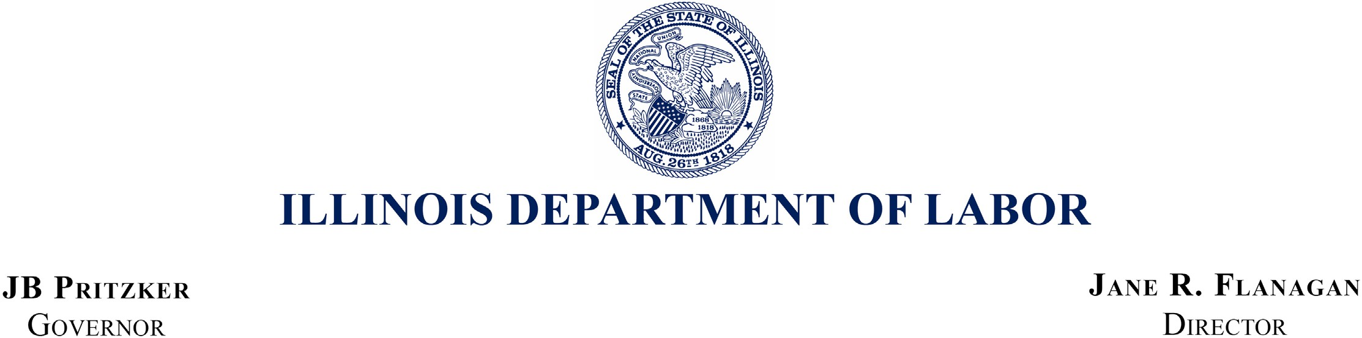

July 2, 2024

William J. Donovan, Regional Administrator

U.S. Department of Labor – OSHA 230 S. Dearborn Street, Room 3244

Chicago, IL 60604

Re: FY 2023 Federal Annual Monitoring and Evaluation Report Dear Mr. Donovan:

Thank you for the opportunity to respond to the FY 2023 Federal Annual Monitoring and Evaluation Report (FAME) for the Division of Occupational Safety and Health (IL OSHA). We are pleased to see that the efforts identified in and implemented through our Corrective Action Plan have resulted in a FY 2023 FAME Report with no findings.

IL OSHA will address the observations identified in the report and remains dedicated to continuing on a path of continuous improvement. We especially appreciate the thoughtful guidance from our State Plan Monitor, Aaron Priddy, and his focus on our mission of ensuring the health and safety of state and local government workers in Illinois.

If you have any questions regarding the FAME or anything else related to IL OSHA, please do not hesitate to contact IL OSHA Division Chief Erik Kambarian at 217-720-8079.

Very best regards,

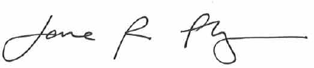

Jane R. Flanagan Director

cc: Suzanne M. Smith, Director of the Office of State Programs Aaron Priddy, Area Director, Fairview Heights, IL

|  |  |  |
| --- | --- | --- |
| Lincoln Tower Plaza | Michael A Bilandic Building | Regional Office Building |
| 524 South 2nd Street, Suite 400 | 160 North LaSalle, Suite C-1300 | 2309 West Main Street, Suite 115 |
| Springfield, Illinois 62701 | Chicago, Illinois 60601-3150 | Marion, Illinois 62959 |
| (217) 782-6206 | (312) 793-2800 | (618) 993-7090 |
| Fax: (217) 782-0596 | Fax: (312) 793-5257 | Fax: (618) 993-7258 |