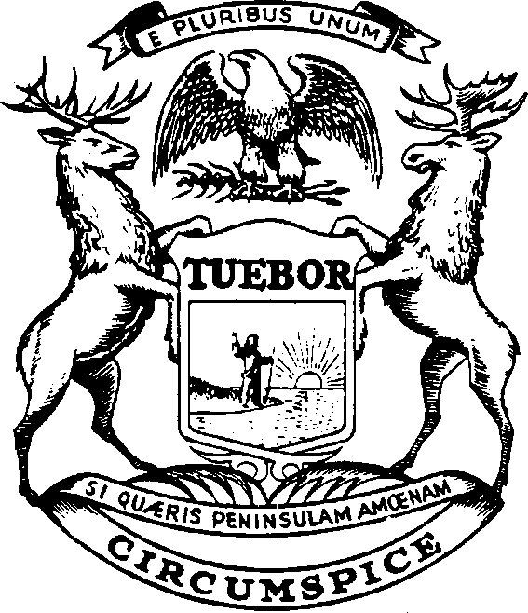

GRETCHEN WHITMER GOVERNOR

State of Michigan

DEPARTMENT OF LABOR AND ECONOMIC OPPORTUNITY MICHIGAN OCCUPATIONAL SAFETY AND HEALTH ADMINISTRATION BARTON G. PICKELMAN, DIRECTOR

SUSAN CORBIN DIRECTOR

June 27, 2024

Mr. William Donovan, Regional Administrator Chicago Region

Occupational Safety and Health Administration (OSHA) United States Department of Labor

230 S. Dearborn Street, Suite 3244

Chicago, Illinois 60604-1694

Subject: MIOSHA's Statement in Response to Comprehensive Federal Annual Monitoring Evaluation (FAME) Report - October 1, 2022, to September 30, 2023

Dear Mr. Donovan:

Thank you for the opportunity to partner with Federal OSHA and work collaboratively during the FY 2023 FAME process to ensure that Michigan's state plan program continues to be effective at protecting the safety and health of workers. This letter provides MIOSHA's statement in response to the FY 2023 FAME report. We request this letter be posted with the FAME report on the OSHA webpage.

MIOSHA prides itself on being a continuous improvement organization and truly values constructive input and feedback. MIOSHA has carefully considered the constructive feedback provided through the evaluation process and FY 2023 FAME report and will continue to take all actions that are appropriate for our state plan program.

Although not required as part of the Corrective Action Plan (CAP) per the revised State Plan Policies and Procedures Manual, the following formal response is provided to you to specifically address the findings and observations noted in the FY 2023 FAME.

**Finding FY 2023-01:** The MIOSHA State Plan has failed to adopt OSHA’s initial FY 2016 maximum and minimum penalty increase and subsequent annual penalty amount increases.

**Recommendation FY 2023-01:** The MIOSHA State Plan should work with their state authorities to complete the legislative changes necessary to enable it to adopt maximum and minimum penalty amounts that are at least as effective as OSHA’s maximum and minimum penalty levels.

**State Response**: MIOSHA has been working with the Michigan state legislature since 2016 to increase the maximum penalties in the Michigan Occupational Safety and Health Act. In 2017,

MIOSHA found a bill sponsor in the state Senate, but the bill never made it to a vote prior to the end of the legislative session. Since that time the agency has attempted to acquire a sponsor for the necessary legislation, but legislators had been reluctant to sponsor another bill partly because OSHA had not made increasing the maximum penalties an “at least as effective as OSHA” issue, nor did OSHA mention the issue as a finding or observation in its FAME. In FY 2023 and FY 2024, MIOSHA used the letter dated September 2, 2021, from Acting Assistant US Secretary of Labor, James Frederick, to the LEO Director on the subject and the FY 2021 FAME finding as impetus and urgency for the legislation. MIOSHA was successful in obtaining a sponsor and senate bill SB 830 was introduced to the Senate Committee on Labor on April 16, 2024, and voted out of the Senate on June 26, 2024.

**Observation FY 2023-OB-01:** Eleven (22%) of the 50 administratively closed whistleblower intakes reviewed were closed without Complainant contact. The Complainant was sent an Administrative Closure letter that claimed there was no protected activity and/or no adverse employment action being the reason no action was being taken on their complaint.

**State Response:** MIOSHA disagrees with the observation. Contrary to the observation language, and as acknowledged by OSHA, in each of the 11 instances, the Complainant was contacted by letter and informed of the specific deficiency in the complaint. The letter requested the Complainant to contact the MIOSHA whistleblower program within a designated number of days if they had additional information or evidence which would change the agency’s determination.

For the record, in the 11 instances referred to by OSHA, MIOSHA is not merely claiming that there was no protected activity and/or no adverse employment action; the Complainants in fact did not include any meaningful description of the protected activity or adverse employment action. The Complainants simply checked a box on an online form indicating potential whistleblower coverage but failed to include any details supporting that claim. In these circumstances, OSHA’s newly revised Whistleblower Investigations Manual (WIM) would have had MIOSHA follow an elaborate administrative closure procedure that even includes obtaining permission from the Complainant to close their complaint.

In response to this FY 2023 FAME observation, by September 1, 2024, MIOSHA will change its administrative closure procedure to approximate the WIM procedure more closely. This adjustment will include a telephone call to the Complainant in addition to the letter, and the letter will now include a list of questions to help the Complainant provide relevant supporting information. This change will result in the adoption of a slightly different procedure from that set forth in the WIM, Chapter 3, IV, but still sufficiently protects the rights afforded to employees under the Michigan Occupational Safety and Health Act.

**Observation FY 2023-OB-02:** Forty-four (88%) of the 50 administratively closed whistleblower case files reviewed lacked a copy of the case Diary Sheet.

**State Response:** MIOSHA agrees with this observation. On April 25, 2024, the agency retrained its whistleblower investigators to include a case Diary Sheet in all case files from the time

MIOSHA receives the complaint. For greater consistency with OSHA terminology, MIOSHA will rename its equivalent form, called the Activity/Telephone Log, as its Diary Sheet by September 1, 2024. For simplicity, MIOSHA will use the Diary Sheet as both the Diary Sheet and Case Activity Log required by the WIM.

**Observation FY 2023-OB-03:** Twenty-one (52%) of the 40 administratively closed whistleblower files that were reviewed during the evaluation, and which were closed without Complainant contact, due to the lack of a protected activity, adverse employment action, jurisdiction, etc., lacked verification of the closure letter’s delivery.

**State Response:** MIOSHA disagrees with the observation as MIOSHA disputes the necessity for a delivery verification procedure in this situation. As a general policy, MIOSHA seeks verification of a letter’s delivery only when the recipient has a statutorily imposed deadline to respond. For administratively closed whistleblower files, there is no statutory deadline for the Complainant to respond. Further, for general business purposes in the United States, barring any legal necessity for confirmation of delivery or receipt, email and US mail are assumed to have been delivered unless the sender receives an error message, or the mail is returned. In response to this observation, by September 1, 2024, MIOSHA will amend its agency instruction adopting the WIM to include an exception to this delivery verification requirement.

**Observation FY 2023-OB-04:** Disparate Treatment was not fully evaluated in 11 (46%) of the 24 full field whistleblower case files that were reviewed. However, it was determined that lack of this full evaluation would not have changed the overall determination of the cases.

**State Response:** MIOSHA disagrees with this observation as Chapter 2 of the WIM does not require an evaluation of disparate treatment in all cases. Likewise, the WIM does not require an evaluation of disparate treatment if the case revealed that the employer lacked knowledge of the protected activity or that the employer had taken no adverse action, which are two of the other four required elements of a violation. Even if the investigation reached the stage of evaluating nexus, of which disparate treatment is an example, an evaluation of disparate treatment, while useful, is not needed to establish nexus. The WIM allows disparate treatment as one piece of evidence that can support nexus. Disparate treatment is not a required element by itself.

As acknowledged by OSHA, the lack of a full evaluation of disparate treatment in these 11 cases would not have changed the final determination. Nonetheless, to evaluate whistleblower complaints more fully, on April 25, 2024, MIOSHA retrained its investigators to ask direct questions about disparate treatment in all investigations that reach the point of evaluating nexus and to document that in each Report of Investigation. The questions are now asked of the Complainant, the Respondent, and witnesses.

In conclusion, MIOSHA appreciated working with the evaluation team. The team was courteous in working with our staff. Please know that MIOSHA's commitment to providing a comprehensive and effective program remains firm.

Thank you for this opportunity to submit a statement in response to the FY 2023 FAME report. If you have questions or would like additional information, please contact me at (517) 284-7772.

Sincerely,

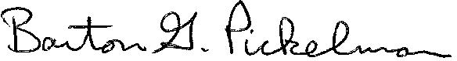

Barton G. Pickelman, CIH MIOSHA Director

cc: Susan Corbin, Director, LEO Sean Egan, Deputy Director, LEO Nancy Nash, OSHA Region V

Darnell Crenshaw, OSHA Region V Todd Jensen, Area Director

Chad Positano, Assistant Area Director