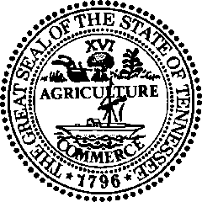

**STATE OF TENNESSEE**

**DEPARTMENT OF LABOR AND WORKFORCE DEVELOPMENT**

**OCCUPATIONAL SAFETY AND HEALTH DIVISION**

**220 French Landing Drive**

**NASHVILLE, TENNESSEE 37243-1002**

**PHONE (615) 741-3161**

July 3, 2024

Mr. Kurt Petermeyer, Regional Administrator

United States Department of Labor

Occupational Safety and Health Administration

61 Forsyth Street Southwest, Room 6T50

Atlanta, Georgia 30303

Re: Tennessee OSHA (TOSHA) Response to the FY 2023 Federal Annual Monitoring and Evaluation (FAME) Report

Mr. Petermeyer:

Our office has received the results of the FY 2023 Comprehensive Federal Annual Monitoring and Evaluation (FAME) report your staff drafted following a visit to our program. The report contained two findings.

First, TOSHA would like to thank your team for the courtesy and professionalism extended to our staff following the on-site visit. We will continue to work with Region 4 staff to improve our state plan and advance our mutual goal of eliminating safety and health hazards from the workplace.

We appreciate the opportunity to post a formal response and to provide comment on the findings published in your report.

Finding FY2023-01, ***In 34 of 68 (50%) files reviewed that had violations, employer knowledge was not adequately documented*,** is another iteration of a subjective finding/observation that has appeared in numerous FAME reports over the past 15 years. When TOSHA requested the evaluator sit with TOSHA during the on-site visit, and in the weeks after, to discuss their specific observation that employer knowledge was not documented, the evaluator refused. TOSHA was unable to speak with a single member of the team of nine over a period of 5 days to have someone elaborate on this finding. In fairness, TOSHA notes that three members of the team did not participate in case file review.

Every file mentioned in the evaluator’s notes contained documentation the CSHO determined the employer, or their designated representative conducted regular workplace evaluations or was present in the work area. Each file correctly documented that the employer was either specifically aware of the hazard, or that the hazard was not temporary in nature and in tandem with the employer’s regular evaluations could have been observed. Lacking any communication, TOSHA has been left to blindly speculate how to interpret this finding.

Nonetheless, and despite the lack of evidence that even a single violation was vacated due to a lack of “employer knowledge” being “adequately documented”, TOSHA will draft a corrective action plan and reallocate resources toward the goal of improving our staff’s ability to “adequately document” employer knowledge.

Finding FY2023-02, ***The Tennessee State Plan has failed to adopt OSHA’s initial FY 2016 maximum and minimum penalty increase and subsequent annual penalty amount increases.***

TOSHA does not dispute this finding, though the Bureau of Labor Statistic data for Total Case Incidence Rates (TCIR) for all industries demonstrates Tennessee’s program to be more effective than the nation as a whole. TOSHA has supported the filing of SB0254/HB0073. However, the bill filed in the first year of session did not gain adequate support in 2023 or in the second year 2024. TOSHA will continue work with state leadership in the legislature to garner the support to change state statute to comply with OSHA’s demand.

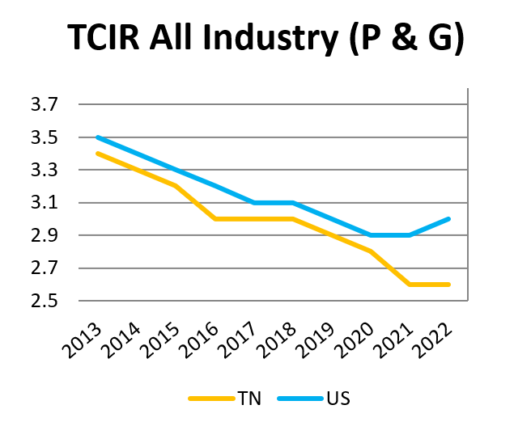

Thank you for the opportunity to provide a formal response to this FY 2023 FAME report. While we are proud of the work we do as an independent program, TOSHA recognizes there is always room for improvement. Conversations with your staff help us to identify inefficiencies, even when they do not rise to the level of a finding. The value of these informal conversations is not captured in your written report; however, it represents the best aspects of cooperation between our respective agencies.

If I can be of any assistance, please do not hesitate to contact me.

Sincerely,

Larry Hunt

Assistant Commissioner

Tennessee OSHA