**GOVERNMENT OF**

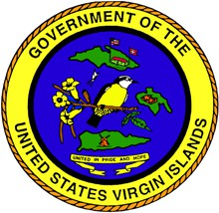

**THE UNITED STATES VIRGIN ISLANDS**

◆



4401 Sion Farm-Christiansted St. Croix, VI 00820-4245

P: (340) 773-1994

***Office of the Commissioner***

2353 Kronprindsens Gade St. Thomas, VI 00802-6221 P: (340) 776-3700

Virgin Islands Division of Occupational Safety and Health (VIDOSH)

Formal Response to FY 2023 Comprehensive FAME Report

June 28, 2024

Richard Mendelson Regional Administrator

Occupational Safety and Health Administration New York Regional Office

201 Varick Street Room 670 New York, NY 10014

SUBJECT: Fiscal Year 2023 Comprehensive Federal Annual Monitoring and Evaluation (FAME) Report for the Virgin Islands Division of Occupational Safety and Health (VIDOSH)

Dear Mr. Mendelson:

Thank you for your letter of June 20, 2024, forwarding the Virgin Island’s State Plan FY 2023 Comprehensive FAME report.

First, I want to sincerely thank you and your staff for the significant support and guidance provided to VIDOSH over the last several years in its attempts to address the serious concerns identified by OSHA in multiple FAME reports and its high-risk grantee status which dates to March 2, 2020.

New York Regional State Plan Monitoring and Whistleblower staff have been highly professional and thorough in carrying out their mandated monitoring responsibilities while also offering their personal time and expertise to VIDOSH’s current staff, all of whom have less than three-year’s experience with the program.

As noted in the 2023 FAME, VIDOSH’s ability to effectively address OSHA’s serious programmatic concerns has been exacerbated by constant turnover and the long-term lingering effects of the catastrophic hurricane damage to public buildings suffered in 2017 from hurricanes Irma and Maria which struck within two weeks of each other. During the evaluation period, the former Director resigned in July 2023 and the Assistant Director who replaced him retired in November 2023.



**The Virgin Islands Department of Labor is an Equal Opportunity Employer with Equal Opportunity Programs. Auxiliary aids and services are available upon request to individuals with disabilities.**

On January 29, 2024, VIDOSH appointed a new Director and is currently in the process of hiring a new Assistant Director, a Consultant and an Administrative Assistant to bring the VIDOSH program up to full staffing.

While the FY 2023 FAME contains thirteen (13) findings and four (4) observations, we believe significant progress has already been made by the new Director and her staff towards significantly reducing and even eliminating a significant number of those findings and observations, while dramatically improving communication and accountability with New York Region staff (beside providing timely monthly required reports to the Region, the VIDOSH Director has been submitting weekly status reports to state plan monitoring staff since February 2024).

Significant improvements have been made in meeting and exceeding inspection goals, reducing lapse times for issuance of citations, conducting follow-up inspections to assure abatement of hazards, closing out inspections in a timelier manner, and actively working on the backlog of Whistleblower cases.

Also, as noted in the 2023 FAME, in February 2024, Region II arranged for a volunteer State Plan Monitoring Mentor from the Virginia State Plan to assist VIDOSH in addressing the FAME findings and observations. The mentor has committed to assisting in the areas of CSHO training, program administration training for the new director, state plan monitoring issues, whistleblower case backlog, open inspection backlog, and open violation abatement backlog, among other activities.

In the area of Whistleblower investigations VOSH has made available both of its senior Whistleblower Investigators to provide training and assistance with OSHA Information System data entry and case file documentation issues.

A critical part of VIDOSH’s efforts to correct noted deficiencies is to not only hire qualified, competent and professional staff, but to provide them with the training and guidance they need to meet and exceed mandated activities and the overall goals of the VIDOSH program. To that end, VIDOSH staff have received critical training in the following areas over the last 18 months.

VIDOSH Director:

* Course z1008 – Introduction to OSHA for New Hires
* Course 1050 – Introduction to Safety Standards for Safety Officers
* Course 1421 – Whistleblower Investigation Fundamentals
* Course 1611 – Whistleblower Interviewing Techniques
* Course 1908 – OSHA Recordkeeping for Compliance Officers
* Course 3280 – Industrial Hygiene Chemistry

Industrial Hygiene Technologist:

* Course 1000 – Initial Compliance
* Course z1008 – Introduction to OSHA for New hires
* Course 1241 – Introduction to Health Standards
* Course 1410 – Inspection Techniques and Legal Aspects
* Course 1421 – Whistleblower Investigation Fundamentals
* Course 1908 – OSHA Recordkeeping for Compliance Officers
* Course 3110 – Fall Protection
* Course 3280 – Industrial Hygiene Chemistry

Safety Compliance Officer:

* Course 1000 – Initial Compliance
* Course 1410 – Inspection Techniques and Legal Aspects
* Course 1421 – Whistleblower Investigation Fundamentals
* Course 1611 – Whistleblower Interviewing Techniques
* Course 3110 – Fall Protection

In addition, through the Virginia mentorship VIDOSH Compliance Safety and Health Officers (CSHO) have recently spent over a week in June in Virginia shadowing Virginia Occupational Safety and Health (VOSH) compliance staff on the following inspections:

* Water Treatment Facility
* Steam Processing Facility
* Construction site (Luxury Senior Living Facility)
* Forklift Repair and Rental (Local Business)
* Construction site (Hospital)
* State Fleet Inspection
* Tree Trimming Inspection
* Construction Inspection – Portable Restrooms/Heat Emphasis

VIDOSH CSHOs were also able to attend Virginia’s 2024 Annual Safety and Health Conference where they received valuable training on safety and health best practices in the following areas:

* Reasonable Suspicion: What employers should know
* Using the MOC Process: Machine Guarding
* Recordkeeping
* Using Behavioral Insights to Shift the Culture of Safety
* Setting Expectations and Managing Stress as a Safety Leader
* General Problem Solving
* Leaving a Safety Legacy
* Ergonomics is Easy
* Flip the script, Achieve Safety Success Through Emotional Management
* Active Threat Response Training

During the VIDOSH staff visit to Virginia, I was also able to personally accompany VIDOSH and VOSH CSHO’s on several inspections and held a meeting with Virginia’s Commissioner of Labor and Industry and Assistant Commissioner for Regulatory Programs to discuss state program administration issues.

The VIDOSH Director is currently planning a visit to Virginia in July 2024 to shadow VOSH Regional Safety and Health Directors to gain a better understanding of field operations (e.g., complaint processing, abatement verification, case file documentation, accident investigation, etc.) and to meet with VOSH Safety and Health Compliance Directors on program administration, grant responsibilities, state plan monitoring activities, etc.

It has been noted more than once during discussions with Region staff that the issues that contributed to OSHA’s and VIDOL’s serious concerns with the state of the VIDOSH program did not occur overnight and cannot be remedied overnight. However, I strongly believe that we have the right management staff in place who are committed to not only meeting mandated activity measures for state plans but also pursuing a process of continuous improvement that will allow VIDOSH to regain its full grantee status.

One example of this effort is the VIDOSH Hurricane Preparedness <https://vidosh.vidol.gov/> initiative developed by the current VIDOSH Director which includes the VIDOSH Hurricane Survival Toolbox Kit, a 4-part series to prepare state and local government agencies for a hurricane and the safety hazards that occur during hurricane response and recovery operations.

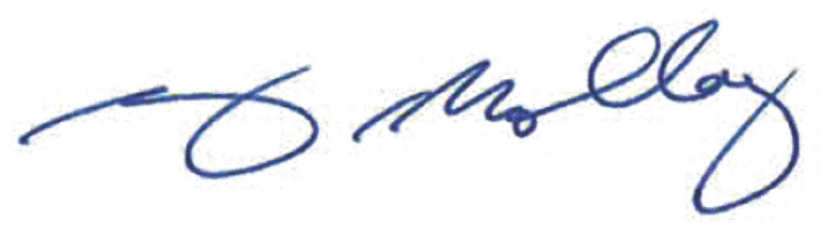

Another instance involves VIDOSH partnering with the Puerto Rico Area Office. The Puerto Rico State Plan has also proven invaluable to VIDOSH, providing opportunities for joint inspections with Puerto Rico CSHOs during their visits to the territory. VIDOSH inspectors have shadowed their Puerto Rico counterparts, gaining valuable insights into conducting inspections across different jurisdictions.

VIDOSH has collaborated with the Puerto Rico Area Office, the Safety in Paradise Program, and the New York Region to organize an upcoming virtual safety summit titled "One OSHA: Working Together to Achieve Results," aligning with OSHA’s updated mission statement. Scheduled during Safe + Sound Week, August 12-18, 2024, the summit aims to engage diverse audiences from the

U.S. Virgin Islands, including both public and private sectors. It will spotlight specific topics such as Safe + Sound, tree trimming/landscaping, heat injury prevention, and top hazards in construction.

In addition, it is our hope that the momentum achieved from this significant effort will move the program forward over the next several years towards achieving its ultimate goal of submitting a developmental plan to reassert concurrent enforcement jurisdiction over private sector employers once again in the Virgin Islands. While it is a lofty goal considering the low points VIDOSH has been through over the last ten years, it is a commitment that I know is shared by those at the highest levels of our government and one we urgently need to pursue for the long-term health and safety of the deserving employees and employers of the Virgin Islands.

In closing, thank you again for the opportunity to provide our response to the FY 2023 Comprehensive FAME report. We very much value your assistance, support and partnership and look forward to an ongoing cooperative and mutually supportive relationship with the New York Region. Please accept our sincere thanks for the valuable services you have provided to the employees and employers of the Virgin Islands Division of Occupational Safety and Health.

Sincerely,

Gary Molloy Commissioner

cc: Nesha Christian-Hendrickson, Assistant Commissioner/Legal Counsel Gregoreese Willocks, Director VIDOSH