

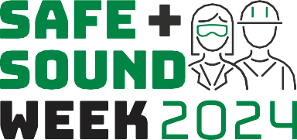

Social Media Toolkit

We’re excited you are participating in Safe + Sound Week 2024! Posting your participation in Safe + Sound Week on social media encourages others to sign up and shows how your safety and health program has improved your workplace. Visit the Safe + Sound Week website for:

* Logos and ready-to-print content
* Graphics on safety and health programs
* Ready-to-use activities for finding workplace hazards
* Select materials available in Spanish

**Join the Conversation**

**Twitter:** [@OSHA_DOL](https://twitter.com/OSHA_DOL) **#SafeAndSoundAtWork LinkedIn:** [Occupational Safety and Health Administration](https://www.linkedin.com/showcase/us-department-of-labor-osha/) **#SanoYSalvoEnElTrabajo**

# Before Safe + Sound Week

**You can use these sample posts and graphics before Safe + Sound Week to show your commitment to safety and health! Find the graphics below at osha.gov/SafeAndSoundWeek/Plan-and-Promote.**

* We are participating in Safe + Sound Week because [fill in reason]. Join us! h[ttps://www.osha.gov/](http://www.osha.gov/)SafeAndSoundWeek/#Register #SafeAndSoundAtWork
* This year we’re recognizing Safe + Sound Week by [list activities]. Learn how you can participate at h[ttps://www.](http://www/) osha.gov/SafeAndSoundWeek #SafeAndSoundAtWork

# During Safe + Sound Week

**Use these sample posts to promote Safe + Sound Week and share photos of your team engaging in safety and health activities, including the Hunt for Hazards using job hazard analysis.**

* At [Organization Name], we completed [activity] to keep our team #SafeAndSoundAtWork.
* At [Organization Name] we know it’s important to get our workers involved in identifying and assessing hazards because [reason]. Our workers agree! #SafeAndSoundAtWork
* Here at [Organization Name] our workers are safety and health leaders. They completed the [activity] #SafeAndSoundAtWork
* [Organization Name] strives for a safe workplace. We want to congratulate our team in completing [activity] #SafeAndSoundAtWork
* Join us on our “Hunt for Hazards” as we find and control workplace hazards. #SafeAndSoundAtWork

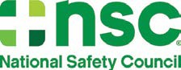





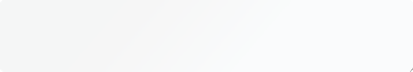

The Hunt for Hazards

# Join the Hunt for Hazards!

## The Case: Join the Hunt for Hazards

[Organization Name] is committed to identifying workplace hazards for a safer environment. Join us in the Hunt for Hazards for Safe + Sound Week 2024! #SafeAndSoundAtWork

## Identify the Suspects: Select a Job and Identify the Hazard

[Organization Name] We identified [job] to assess in our Hunt for Hazards! [link to activity] #SafeAndSoundAtWork

## Gather Evidence

At [Organization Name] we involve all our workers in our Hunt for Hazards. One thing we’ve learned is [lesson]. [link to activity] #SafeAndSoundAtWork

## It’s a Stakeout: Search for Hazards on the Job

Safe + Sound Week is a great time to Hunt for Hazards! [link to activity] #SafeAndSoundAtWork

## Cracked the Case! Choose and Implement Controls

[Organization Name] We identified [hazard + control] in our Hunt for Hazards! [link to activity] #SafeAndSoundAtWork

## Recognize Your Accomplishments!

[Organization Name] is wrapping up Safe + Sound Week 2024! Together we cracked the case in our Hunt for Hazards to keep our workers #SafeAndSoundAtWork.

# After Safe + Sound Week

Share photos of some of your favorite memories or lessons learned during Safe + Sound Week activities!

* [Organization Name] was proud to participate in Safe + Sound Week 2024! Here were some of our favorite moments: [Share pictures of your workers/members participating in Safe + Sound Week events] #SafeAndSoundAtWork
* [Organization Name] is a proud [participant/partner] of Safe + Sound Week for a safer and healthier workplace. Our team learned [lesson] #SafeAndSoundAtWork

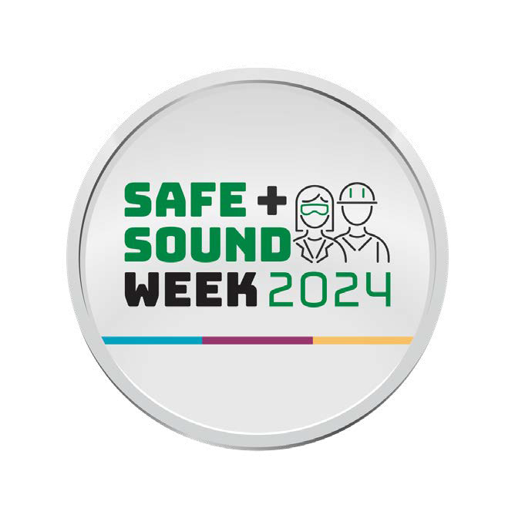

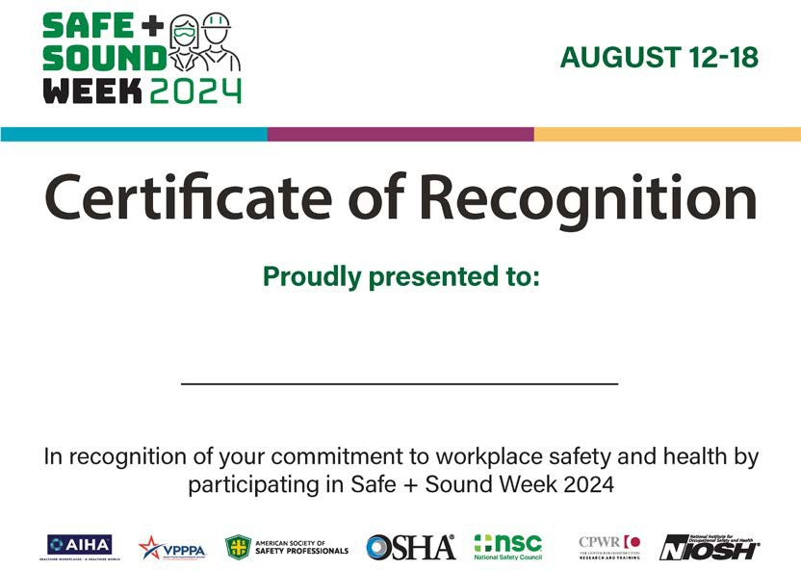

**osha.gov/SafeAndSoundWeek #SafeAndSoundAtWork SafeAndSoundCampaign@dol.gov**

# Past Safe + Sound Week Examples

